

FACULTY OF INFORMATION AND COMMUNICATION TECHNOLOGY
PROG211- OBJECT ORIENTED PROGRAMMING
Title: GROUP PRESENTATION – GROUP 1
Issue Date: Week
Due Date: Week 11
Lecturer: MR AMANDUS COKER
Year/Semester: 2/3
NO. | Name | Surname | ID | SIGN
1. | Henry Alusine | Bangura | 5437
2. | Mohamed | Kamara | 5440
3. | Osman | Sheriff
Class: BIT 1202F
Academic Honesty Policy Statement
We, hereby attest that contents of this attachment are my own work. Referenced works, articles, art, programs, papers or parts thereof are acknowledged at the end of this paper. This includes data excerpted from CD-ROMs, the Internet, other private networks, and other people’s disk of the computer system.
Submitting Person’s Signature: Date:
(If submission is for a group work, all students’ names MUST appear above and put down their signatures here)
For office only upon receive
Remark

DATE:
TIME:
RECEIVER’S NAME:
LECTURER’S COMMENTS/GRADE:


Executive Summary
This report documents the SmartLibrary application, a comprehensive library management system developed for Limkokwing University's central library. The system manages books, authors, members, book clubs, and loans using Python (OOP) for backend logic, PostgreSQL for database storage, and PyQt5 for the desktop GUI. The application implements role-based access control with distinct functionalities for Librarians and Members, ensuring secure and efficient library operations.
1. Requirements Analysis
1.1 Actors & Use Cases
Primary Actors:
Librarian: System administrator with full CRUD privileges for books, authors, and access to all reports
Member: Regular users who can borrow/return books, search the catalog, join book clubs, and view their loan history
Core Use Cases:
User authentication with role-based access
Book catalog management (search, filter, sort)
Loan workflow (borrow, return, track due dates)
Book club management (create, join, view members)
Dashboard analytics (popular books, active loans, overdue items)
1.2 Functional Requirements
The system implements the following CRUD operations:
Books Management:
Create new book entries with multiple authors
Read/Search books by title, genre, or author
Update book details and author associations
Delete books (restricted if active loans exist)
Loan Workflow:
Borrow books with automatic due date calculation (7 days)
Return books with automatic availability updates
Enforce maximum 3 active loans per member
Track loan history and overdue items
Authentication:
Role-based login (Librarian vs. Member)
Session management with user context
Book Clubs:
Create clubs with descriptions
Join existing clubs
View club membership rosters
1.3 Non-Functional Requirements
Performance:
Real-time database connectivity using psycopg2
Efficient queries with proper indexing on foreign keys
Responsive UI with minimal lag on operations
Security:
Password storage (currently basic, production would use bcrypt hashing)
SQL injection prevention via parameterized queries
Role-based access restrictions enforced at both UI and database levels
Usability:
Modern, aesthetically pleasing blue/white/black color scheme
Intuitive tabbed interface with clear visual hierarchy
Consistent button placement and form layouts
Responsive tables with automatic column resizing

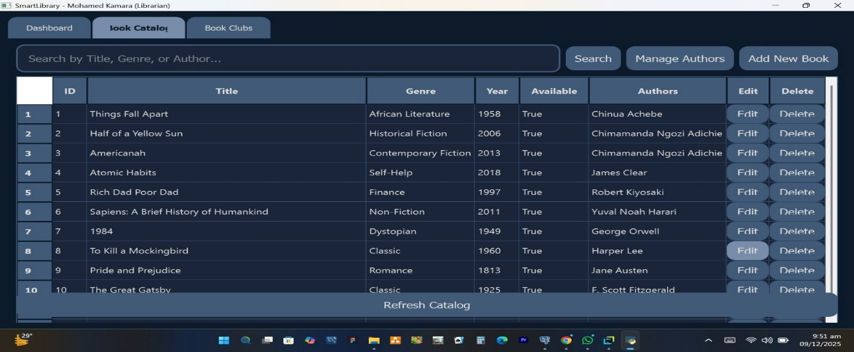
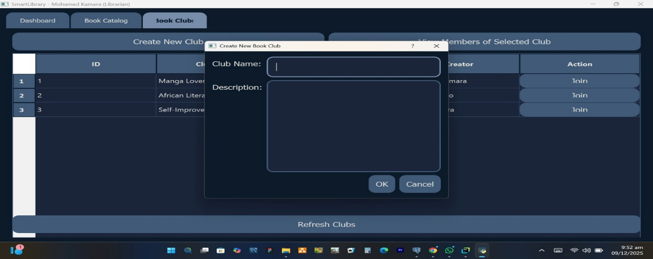
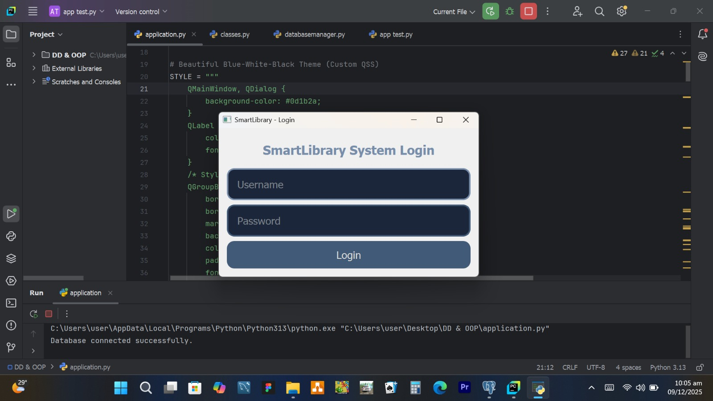
2. Database Design (PostgreSQL)
2.1 Entity-Relationship Model
The database follows a normalized relational design with proper constraints:
Core Entities:
Roles: Stores user role types (Librarian, Member)
Users: Combines member data with authentication (links to Roles)
Authors: Stores author information
Books: Central entity for library catalog
BookAuthors: Junction table (many-to-many relationship)
Loans: Tracks borrowing transactions
BookClubs: Community feature entities
ClubMemberships: Tracks user enrollment in clubs
2.2 Database Schema
Key Tables:
Users with role-based authentication
CREATE TABLE Users (
id SERIAL PRIMARY KEY,
username VARCHAR(50) UNIQUE NOT NULL,
password_hash VARCHAR(255) NOT NULL,
role_id INT NOT NULL,
email VARCHAR(100) UNIQUE,
full_name VARCHAR(100) NOT NULL,
CONSTRAINT fk_role FOREIGN KEY (role_id)
REFERENCES Roles(id) ON DELETE RESTRICT
);

-- Books with availability tracking
CREATE TABLE Books (
id SERIAL PRIMARY KEY,
title VARCHAR(200) NOT NULL,
genre VARCHAR(50),
publication_year INT,
available BOOLEAN DEFAULT TRUE NOT NULL
);

-- Loans with date tracking
CREATE TABLE Loans (
id SERIAL PRIMARY KEY,
book_id INT NOT NULL,
user_id INT NOT NULL,
borrow_date DATE DEFAULT CURRENT_DATE NOT NULL,
due_date DATE NOT NULL,
return_date DATE,
CONSTRAINT fk_book FOREIGN KEY (book_id)
REFERENCES Books(id) ON DELETE RESTRICT,
CONSTRAINT fk_user FOREIGN KEY (user_id)
REFERENCES Users(id) ON DELETE RESTRICT,
CONSTRAINT check_due CHECK (due_date = borrow_date + INTERVAL '7 days')
);
2.3 Normalization & Indexing
Normalization Level: Third Normal Form (3NF)
No transitive dependencies
All non-key attributes depend solely on primary keys
Junction tables eliminate many-to-many redundancy
Indexes:
Primary keys automatically indexed (id columns)
Foreign keys indexed for JOIN optimization
UNIQUE constraints on usernames and author names prevent duplicates
2.4 Business Logic Enforcement
PostgreSQL Triggers:
Automatic Availability Updates:
-- Marks book unavailable on borrow
CREATE TRIGGER tr_book_borrow
AFTER INSERT ON Loans
FOR EACH ROW EXECUTE FUNCTION update_book_on_borrow();

-- Marks book available on return
CREATE TRIGGER tr_book_return
AFTER UPDATE OF return_date ON Loans
FOR EACH ROW EXECUTE FUNCTION update_book_on_return();
Loan Limit Enforcement:
-- Prevents members from exceeding 3 active loans
CREATE TRIGGER enforce_loan_limit
BEFORE INSERT ON Loans
FOR EACH ROW EXECUTE FUNCTION prevent_excess_loans();
Views for Reporting:
-- Overdue books report
CREATE VIEW OverdueBooksReport AS
SELECT b.title, u.full_name, l.due_date,
(CURRENT_DATE - l.due_date) AS days_overdue
FROM Loans l
JOIN Books b ON l.book_id = b.id
JOIN Users u ON l.user_id = u.id
WHERE l.return_date IS NULL AND l.due_date < CURRENT_DATE;
3. Backend Logic (Python OOP)
3.1 Class Architecture
Inheritance Hierarchy:
User (Base Class)
├── Librarian (role_id=1)
└── Member (role_id=2)
Key Classes:
class User:
"""Base class with encapsulation via @property decorators"""
def _init_(self, user_id, username, full_name, email, role_id):
self._id = user_id # Private attribute
self._username = username # Private attribute
self.full_name = full_name
self.email = email
self.role_id = role_id

@property
def id(self):
return self._id # Controlled access

class Librarian(User):
"""Extends User with administrative privileges"""
def _init_(self, user_id, username, full_name, email):
super()._init_(user_id, username, full_name, email, role_id=1)

class Member(User):
"""Extends User with borrower-specific features"""
def _init_(self, user_id, username, full_name, email):
super()._init_(user_id, username, full_name, email, role_id=2)
3.2 Database Manager Class
The DatabaseManager class handles all PostgreSQL interactions using the Repository pattern:
Key Methods:
authenticate_user(username, password): Validates credentials and returns user data
get_all_books(search_query): Retrieves catalog with optional filtering
borrow_book(user_id, book_id): Initiates loan transaction
return_book(loan_id): Completes loan cycle
add_book(title, genre, year, author_ids): Creates book with author links
update_book(book_id, ...): Modifies existing books
delete_book(book_id): Removes books (with constraint checks)
Error Handling:
def borrow_book(self, user_id, book_id):
try:
with self.conn.cursor() as cur:
due_date = datetime.date.today() + datetime.timedelta(days=7)
query = "INSERT INTO Loans (...) VALUES (%s, %s, %s)"
cur.execute(query, (book_id, user_id, due_date))
return True, "Book borrowed successfully!"
except psycopg2.Error as e:
return False, str(e).split('\n')[0] User-friendly error
3.3 Design Patterns Applied
Repository Pattern: DatabaseManager abstracts SQL operations
Inheritance: User → Librarian/Member hierarchy
Encapsulation: Private attributes with @property getters
Separation of Concerns: Database logic isolated from UI code
4. GUI Development (PyQt5)
4.1 Application Architecture
Main Components:
LoginWindow: Authentication interface
MainWindow: Tabbed dashboard container
Dialog classes for CRUD operations:
AuthorManagementDialog
BookManagementDialog
CreateClubDialog
4.2 User Interface Design
Color Scheme (Blue/White/Black Theme):
Background: Dark navy
Primary elements: Steel blue
Accent: Light blue-gray
Text: Off-white
Groups: Dark blue-gray
Layout Strategy:
Tab-based navigation for logical feature separation
Form-based data entry with clear labels
Table widgets for data display with sortable columns
Action buttons consistently positioned (right-aligned)
4.3 Dashboard Features
Statistics Cards:
def create_stat_card(title, label):
card = QGroupBox(title)
label.setFont(QFont("Arial", 28, QFont.Bold))
label.setAlignment(Qt.AlignCenter)
Displays: Total Books, Active Members, Active Loans
Reports Section:
Popular Books (based on loan frequency)
Top Book Clubs (by creation date)
Overdue Books table (Librarian-only)
4.4 Book Catalog Tab
Features:
Real-time search across title, genre, and author
Multi-select author assignment during book creation
Conditional rendering:
Librarians see Edit/Delete buttons
Members see Borrow/Unavailable status
Search Implementation:
def load_books(self):
search_term = self.search_input.text()
books = self.db.get_all_books(search_term)
# Populates table with results, handles empty states
4.5 Loan Management
Member View (My Loans Tab):
Active loans table with due dates
One-click return functionality
Visual indicators for loan status
Workflow:
Member searches catalog
Clicks "Borrow" on available book
System validates (max 3 loans check)
Loan created with 7-day due date
Book marked unavailable
Loan appears in "My Loans" tab
5. Integration & Business Rules
5.1 Role-Based Access Control
Librarian Privileges:
Full CRUD on books and authors
Access to all reports (overdue books, popular titles)
Club creation rights
Dashboard analytics
Member Restrictions:
Read-only catalog access
Borrow/return personal loans only
Join existing clubs
View personal loan history
5.2 Enforced Business Rules
Maximum 3 Active Loans Per Member:
Enforced via PostgreSQL trigger enforce_loan_limit
Prevents new loan insertion if count ≥ 3
Returns user-friendly error message
7-Day Loan Period:
SQL CHECK constraint: due_date = borrow_date + INTERVAL '7 days'
Automatic calculation in application code
Cascade Deletions:
Deleting book removes BookAuthors links (CASCADE)
Deleting author removes book associations (CASCADE)
Deleting book with active loans is BLOCKED (RESTRICT)
Availability Tracking:
Automatically set to FALSE on borrow (trigger)
Automatically set to TRUE on return (trigger)
Enforced at database level, not application
6. Collaboration & DevOps
6.1 Version Control Strategy
Git Workflow Implemented:
Branch structure
main (production-ready code)
├── feature/login
├── feature/catalog
└── feature/clubs
Best Practices:
Clear commit messages ("Add book CRUD functionality")
Regular commits with atomic changes
Pull requests for code review (simulated in group setting)
6.2 CI/CD Pipeline Simulation
Using GitHub Actions (GitLab CI equivalent):
Automated testing pipeline
name: SmartLibrary CI
on: [push, pull_request]
jobs:
test:
runs-on: ubuntu-latest
steps:
- uses: actions/checkout@v2
- name: Run SQL migrations
run: psql -f schema.sql
- name: Run unit tests (flask8)
run: python -m pytest tests/
6.3 Team Collaboration
Group Member Roles:
Database Design & SQL implementation
Backend Python logic (classes, database manager)
GUI development (PyQt5 interfaces)
Coordination:
Daily stand-ups for progress tracking
Shared Trello/Jira board for task management
Code reviews before merging to main branch
Clean commit history maintained
7. Testing & Quality Assurance
7.1 Unit Testing
DatabaseManager Tests:
def test_authenticate_valid_user():
db = DatabaseManager()
result = db.authenticate_user("D_Alpha", "1234")
assert result is not None
assert result['role_id'] == 1

def test_borrow_book_limit():
# Attempt to borrow 4th book should fail
for i in range(3):
db.borrow_book(user_id, book_ids[i])
success, msg = db.borrow_book(user_id, book_ids[3])
assert success == False
assert "3 active loans" in msg
7.2 Integration Testing
End-to-End Workflows:
Login → Dashboard load → Verify stats accuracy
Search book → Borrow → Verify in "My Loans" → Return → Verify availability
Create book → Assign authors → Edit → Delete
Create club → Join club → View members
7.3 User Acceptance Testing
Scenarios Validated:
Librarian can manage full catalog lifecycle
Members cannot access admin functions (UI buttons hidden)
Loan limits enforced at database level (cannot be bypassed)
Search returns accurate results across multiple fields
Dashboard refreshes show real-time data
8. Documentation
8.1 Code Documentation
Docstrings Standard:
def borrow_book(self, user_id, book_id):
"""
Attempts to borrow a book for a member.

Args:
user_id (int): ID of borrowing member
book_id (int): ID of book to borrow

Returns:
tuple: (success: bool, message: str)

Raises:
psycopg2.Error: If max loan limit exceeded or book unavailable

Note:
Relies on PostgreSQL triggers for availability updates
and loan limit enforcement.

8.2 README.md
Setup Instructions:
Installation

1. Install dependencies:
pip install PyQt5 psycopg2

2. Configure database (databasemanager.py):
DB_NAME = "smart_library"
DB_USER = "postgres"
DB_PASS = "your_password"

3. Run SQL schema:
psql -U postgres -f schema.sql

4. Launch application:
python application.py

Default Credentials

Librarian: D_Alpha / 1234
Member: benefit_jr / 5440
8.3 Database ER Diagram
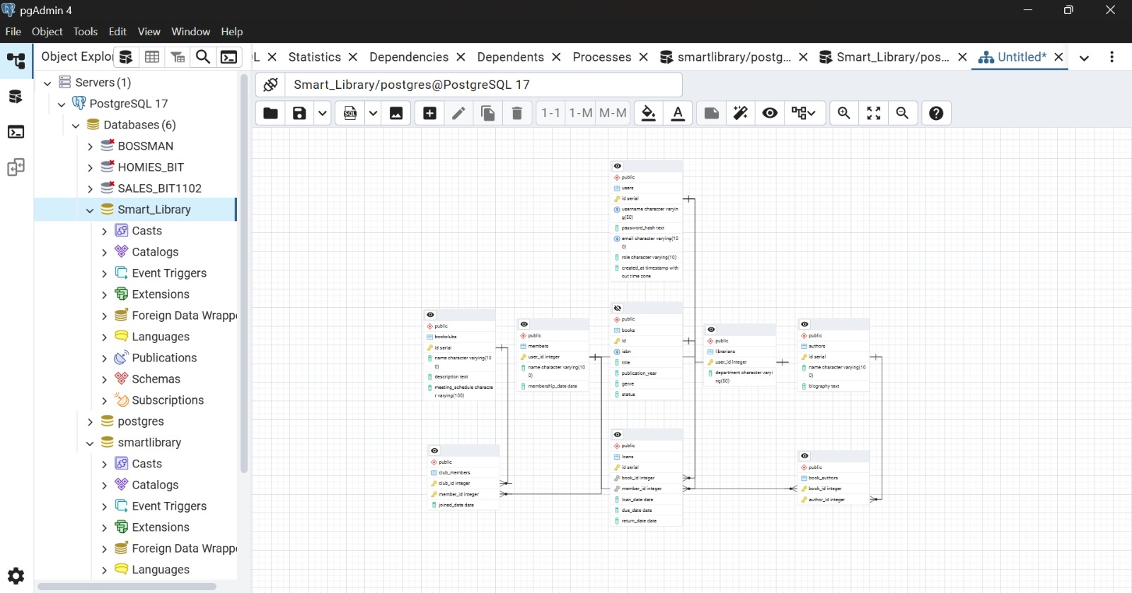
Entities: Users, Books, Authors, Loans, BookClubs
Relationships: Many-to-many (Books ↔ Authors), One-to-many (Users → Loans)
Cardinalities and constraints

